All about food 5. Razred

March 17th, 2020

Dragi učenici,
nadam se da ste dobro što vam od srca želim.
Od sada ćemo se družiti online pa vam šaljem zadatke za ovaj tjedan ( 17. 03.- 20.03.2020.)

Osim udžbenika i radne bilježnice u fizičkom obliku ,preporučam vam da koristite iste u digitalnom obliku jer tamo možete slušati tekstove i vježbati izgovor.Da biste to mogli, otvorite stranicu expressdigibooks.com i tamo aktivirajte svoj račun kako biste pristupiti odjeljku My e- books.
Upute o registraciji imate na prvoj stranici vašeg udženika i radne bilježnice.

Zadaci za vježbu
Task 1

Book- page 58-59 - look at the picture and complete exercise 1 a with the following words :

biscuits,pasta, fruit juice ,meat ,cucumber ,strawberries , salt

Sve nove riječi možete pronaći u udžbeniku na stanici 174 (module 4)
Task 2
Register to your expressdigibook and watch the video

Task 3
Look at the pictures and list the food and drinks under the right title :

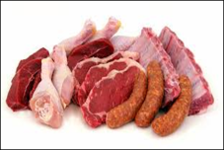 animal products 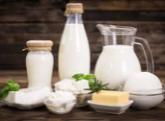 dairy products 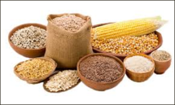 grain

animal products | dairy products | grain | fruit | vegetables | other

Task 4
Look at the examples in exercise 3 and complete the sentences about the food you like or dislike:

Example : I love/hate cucumber.

I love ______________________________.
I really like _________________________.
I quite like ___________________________.
I don't like ___________________________.
I hate _______________________________.

Task 5
Workbook – page 30 – complete the exercises 1,2,3

Task 6
Describe your food :
My breakfast | My lunch | My dinner

Task 7
Book page 134 – 1) label the pictures 2) Circle the odd man out

4a Sweet food
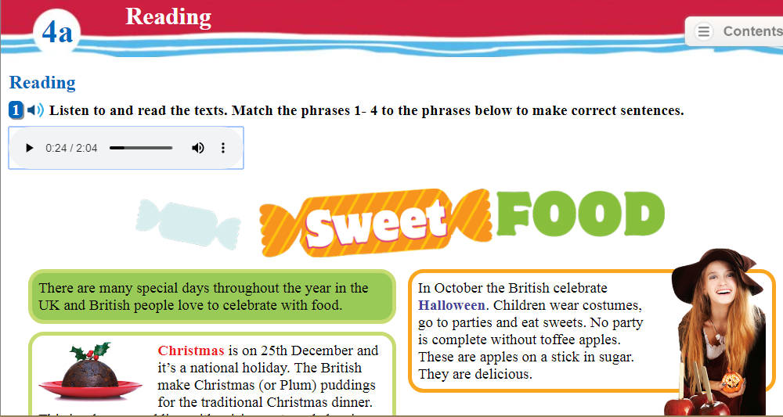

Task 1
Book –page 60
Read the text , check the new words on page 174 ( 4a)

Task 2
Book – do the exercises 1 and 2

Task 3
Match the pictures to the cake:

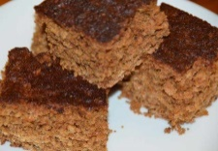 1 2 3 4

CHRISTMAS PUDDING TOFFEE APPLES PARKIN HOT CROSS BUNS

Task 4
Complete the chart as in the example :

 | Christmas | Halloween | Good Friday | Bonfire Night
FOOD | brown pudding
TRADITION | to hide a coin

buns protect the house toffee apples fireworks,parties and fires

hot cross buns parkin scary costumes and parties

Task 5
Book - page 61 Celebrations

Look at the photos and match the greetings to the celebration( exercise 4):

New Year | April Fools' Day | Valentine's Day | Easter

Task 6

Execise 6
Write an invitation card
Use the phrases below:

New Year 11:00 pm New Year's Eve funny clothes

on 31st December 12 King Tomislav Street 01- 3360 - 781

Task 7

Choose a celebration in Croatia and complete the chart

Name ________________________

TIME
FOOD
TRADITION
PRESENTS yes/no
GREETING /WISH

Ovo je sve za ovaj tjedan. Riješite ponuđene zadatke i svakako pokušajte pratiti lekcije u online udžbeniku.

Želim vam uspjašan rad i čuvajte sebe i svoje.

Profesorica Vandekar

