5.a,b,c razred

1. sat 01.06.2020.

Task 1

Student's book- page 80
Open your books and match the words to the pictures:
(otvorite udžbenik i povežite riječi sa slikama)

Clothes Accessories Footwear
(odjeća) (dodaci) (obuća)

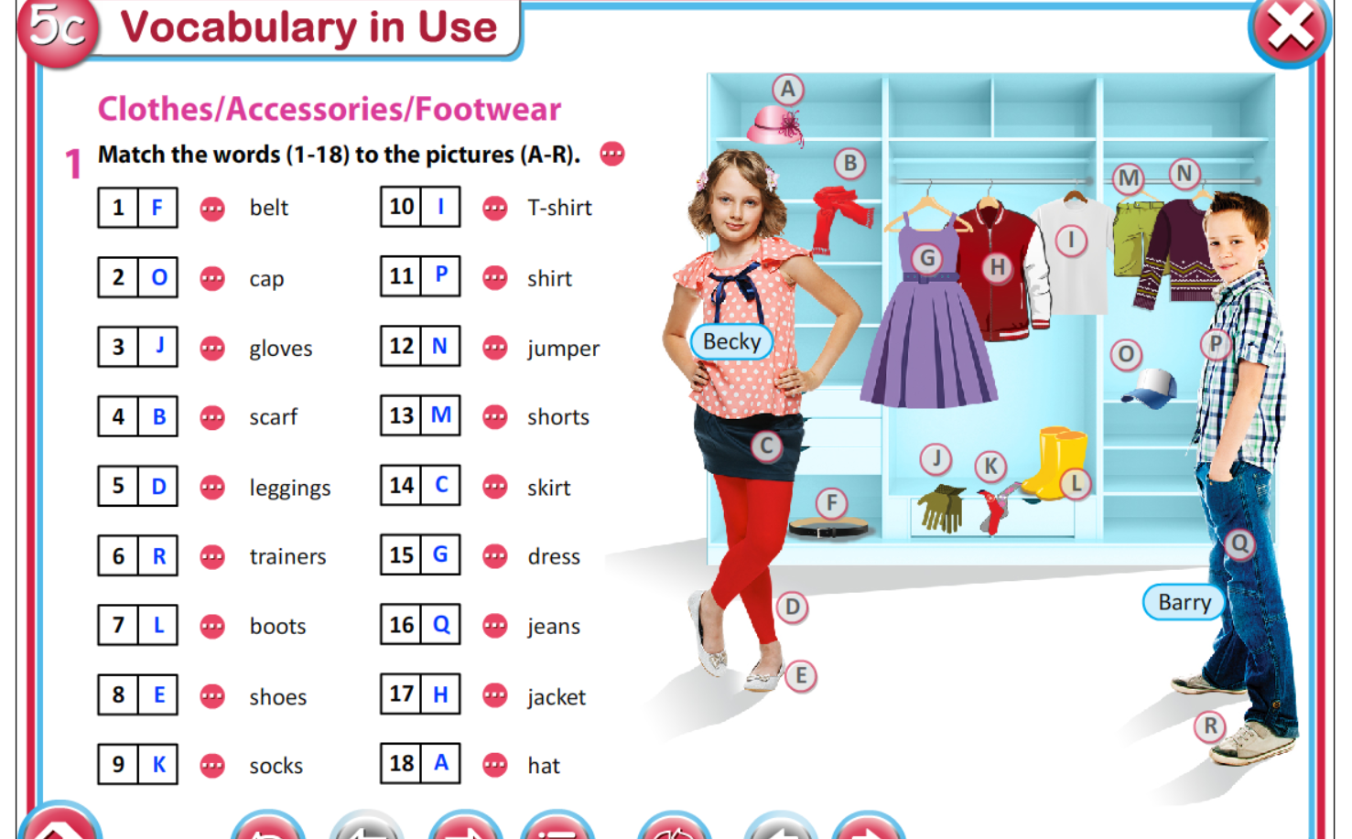
Nepoznate riječi možete naći u udžbeniku na stranici 175 – 5c

Task 2
Describe what are Becky ,Barry and you wearing (opiši što nose Becky,Barry i ti)

BECKY | BARRY | ME

Task 3

Open your workbooks – page 42 – exercises – 1,2,3

Task 4

Play the quizes :

https://wordwall.net/hr/resource/538208/engleski-jezik/clothes

https://wordwall.net/hr/resource/2020968/engleski-jezik/clothes-accessories-footwear

Your homework for this week is complete all the tasks coloured yellow
( vaša zadaća za ovaj tjedan- dopuni sve zadatke označene žuto )

Friday- 5th June , 2020

