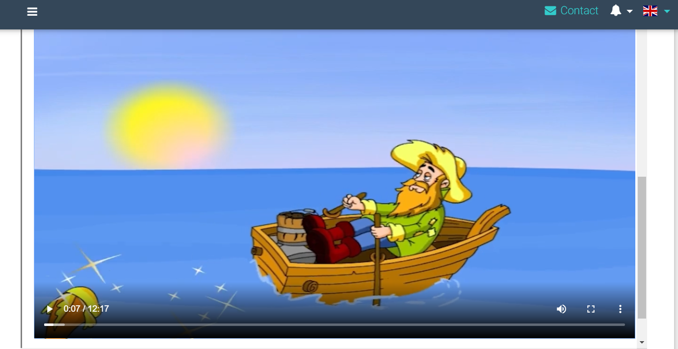
5. razred

3. sat – 24.04.2020.

The Fisherman and the Fish

Hi everyone ,follow these tasks

Task 1

Watch the video and copy the 6 sentences as examples for compariosn of adjectives

https://screencast-o-matic.com/watch/cYf0qbAO3g

Task 2

Copy the words about the story

Task 3
Watch the video - THE FISHERMAN AND THE FISH
WEBSITE - nastava.alfa.hr

Read the story – book page 116

Task 4
do the exercises in your book on page 117

That's all for today .NO HOMEWORK OVER THE WEEKEND

Have fun for the weekend

