Uskoro nam se bliži Dan planeta Zemlje. Pokažimo Zemlji da se brinemo o njoj, reciklirajući. Uz malo dobre volje, kartona, boje i kreativnosti mogu nastati prekasne stvari.

[[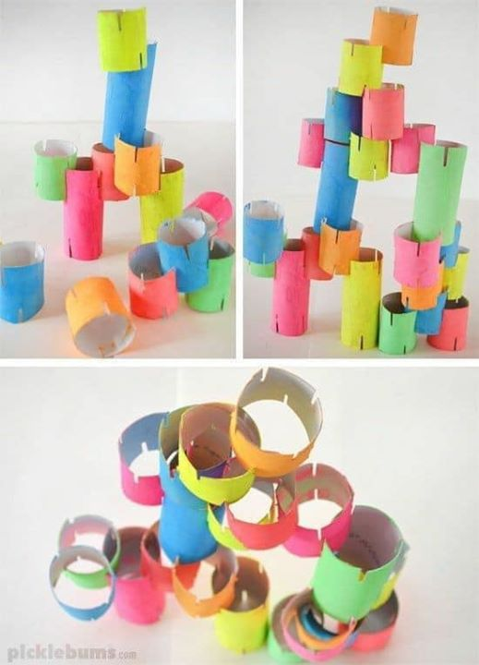](https://www.facebook.com/975629142631613/photos/pcb.1338005859727271/1338004699727387/?type=3&__tn__=HH-R&eid=ARBBhTBROzX739qzJlQ2OtKMMKEBn9JUqCU3stNIFUVJa9wrgGIS4YfzQKMWwE8KzypIgqeppGVJIYO0&__xts__%5b0%5d=68.ARCPnvvBdtOj65hMZVGwwBzCh8dmD4So-U-b17rUUkT4uD0IbdaSjDQWQDUKQJANJ7Ie-R3oe6sbp_ikxVO2yVyvo5qu9AQkA2BZt_MCYEVSMJUgB3uHlim1BupgEWMsYqyMHgOStXsUWSOW_TVysELdWe7lPmti-x17Y10ysOpgN83Kj0ALFSKbNife82RbLAefM6H9n7EKEKWDdJ1hnFCxB_EAz77qhYkJ-LwpuzvIw1eaPYlYSElw-ekCCbrfn37g2EDt-UQSh2SF3DVaT7RcfyTZywXjzNyzEp7wqt7yxJo4Nru5Binu5R6mB_XZ_6XsHvlueql9y6atseF8Ol9Slg)](https://www.facebook.com/975629142631613/photos/pcb.1338005859727271/1338004699727387/?type=3&__tn__=HH-R&eid=ARBBhTBROzX739qzJlQ2OtKMMKEBn9JUqCU3stNIFUVJa9wrgGIS4YfzQKMWwE8KzypIgqeppGVJIYO0&__xts__%5B0%5D=68.ARCPnvvBdtOj65hMZVGwwBzCh8dmD4So-U-b17rUUkT4uD0IbdaSjDQWQDUKQJANJ7Ie-R3oe6sbp_ikxVO2yVyvo5qu9AQkA2BZt_MCYEVSMJUgB3uHlim1BupgEWMsYqyMHgOStXsUWSOW_TVysELdWe7lPmti-x17Y10ysOpgN83Kj0ALFSKbNife82RbLAefM6H9n7EKEKWDdJ1hnFCxB_EAz77qhYkJ-LwpuzvIw1eaPYlYSElw-ekCCbrfn37g2EDt-UQSh2SF3DVaT7RcfyTZywXjzNyzEp7wqt7yxJo4Nru5Binu5R6mB_XZ_6XsHvlueql9y6atseF8Ol9Slg)

[[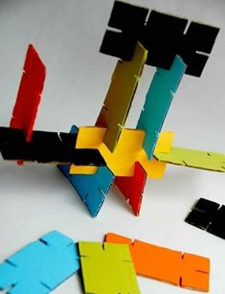](https://www.facebook.com/975629142631613/photos/pcb.1338005859727271/1338004716394052/?type=3&__tn__=HH-R&eid=ARCJnf-oCjTAcjxgIDF39A-YlnT0SpI5kJTVZgyLLDzvXbgyiDg7pkFH6I3-H1kZKFuWwiS5SJtyB29G&__xts__%5b0%5d=68.ARCPnvvBdtOj65hMZVGwwBzCh8dmD4So-U-b17rUUkT4uD0IbdaSjDQWQDUKQJANJ7Ie-R3oe6sbp_ikxVO2yVyvo5qu9AQkA2BZt_MCYEVSMJUgB3uHlim1BupgEWMsYqyMHgOStXsUWSOW_TVysELdWe7lPmti-x17Y10ysOpgN83Kj0ALFSKbNife82RbLAefM6H9n7EKEKWDdJ1hnFCxB_EAz77qhYkJ-LwpuzvIw1eaPYlYSElw-ekCCbrfn37g2EDt-UQSh2SF3DVaT7RcfyTZywXjzNyzEp7wqt7yxJo4Nru5Binu5R6mB_XZ_6XsHvlueql9y6atseF8Ol9Slg) [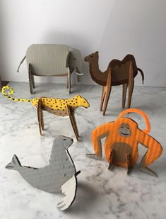](https://www.facebook.com/975629142631613/photos/pcb.1338005859727271/1338004779727379/?type=3&__tn__=HH-R&eid=ARAiT45Je4gggYYgzQgR4FrgueRINcZSuiiiMn83OV4u14Pi3DbqsraIEF6c2xMCSurVObN7G0vpuASN&__xts__%5b0%5d=68.ARCPnvvBdtOj65hMZVGwwBzCh8dmD4So-U-b17rUUkT4uD0IbdaSjDQWQDUKQJANJ7Ie-R3oe6sbp_ikxVO2yVyvo5qu9AQkA2BZt_MCYEVSMJUgB3uHlim1BupgEWMsYqyMHgOStXsUWSOW_TVysELdWe7lPmti-x17Y10ysOpgN83Kj0ALFSKbNife82RbLAefM6H9n7EKEKWDdJ1hnFCxB_EAz77qhYkJ-LwpuzvIw1eaPYlYSElw-ekCCbrfn37g2EDt-UQSh2SF3DVaT7RcfyTZywXjzNyzEp7wqt7yxJo4Nru5Binu5R6mB_XZ_6XsHvlueql9y6atseF8Ol9Slg) [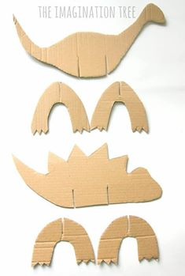](https://www.facebook.com/975629142631613/photos/pcb.1338005859727271/1338004786394045/?type=3&__tn__=HH-R&eid=ARDR-2HY31Ez-2pUFzeawWecU9btHiyWE-m8ktserRqQfEfav-vHmIRl1H9RQ-j-IBgUTZB-8jU5Arnr&__xts__%5b0%5d=68.ARCPnvvBdtOj65hMZVGwwBzCh8dmD4So-U-b17rUUkT4uD0IbdaSjDQWQDUKQJANJ7Ie-R3oe6sbp_ikxVO2yVyvo5qu9AQkA2BZt_MCYEVSMJUgB3uHlim1BupgEWMsYqyMHgOStXsUWSOW_TVysELdWe7lPmti-x17Y10ysOpgN83Kj0ALFSKbNife82RbLAefM6H9n7EKEKWDdJ1hnFCxB_EAz77qhYkJ-LwpuzvIw1eaPYlYSElw-ekCCbrfn37g2EDt-UQSh2SF3DVaT7RcfyTZywXjzNyzEp7wqt7yxJo4Nru5Binu5R6mB_XZ_6XsHvlueql9y6atseF8Ol9Slg)](https://www.facebook.com/975629142631613/photos/pcb.1338005859727271/1338004716394052/?type=3&__tn__=HH-R&eid=ARCJnf-oCjTAcjxgIDF39A-YlnT0SpI5kJTVZgyLLDzvXbgyiDg7pkFH6I3-H1kZKFuWwiS5SJtyB29G&__xts__%5B0%5D=68.ARCPnvvBdtOj65hMZVGwwBzCh8dmD4So-U-b17rUUkT4uD0IbdaSjDQWQDUKQJANJ7Ie-R3oe6sbp_ikxVO2yVyvo5qu9AQkA2BZt_MCYEVSMJUgB3uHlim1BupgEWMsYqyMHgOStXsUWSOW_TVysELdWe7lPmti-x17Y10ysOpgN83Kj0ALFSKbNife82RbLAefM6H9n7EKEKWDdJ1hnFCxB_EAz77qhYkJ-LwpuzvIw1eaPYlYSElw-ekCCbrfn37g2EDt-UQSh2SF3DVaT7RcfyTZywXjzNyzEp7wqt7yxJo4Nru5Binu5R6mB_XZ_6XsHvlueql9y6atseF8Ol9Slg)

[Pokušaj se i ti poigrati, sigurno ćeš uspjeti  !!!!!!!!!!](https://www.facebook.com/975629142631613/photos/pcb.1338005859727271/1338004786394045/?type=3&__tn__=HH-R&eid=ARDR-2HY31Ez-2pUFzeawWecU9btHiyWE-m8ktserRqQfEfav-vHmIRl1H9RQ-j-IBgUTZB-8jU5Arnr&__xts__%5B0%5D=68.ARCPnvvBdtOj65hMZVGwwBzCh8dmD4So-U-b17rUUkT4uD0IbdaSjDQWQDUKQJANJ7Ie-R3oe6sbp_ikxVO2yVyvo5qu9AQkA2BZt_MCYEVSMJUgB3uHlim1BupgEWMsYqyMHgOStXsUWSOW_TVysELdWe7lPmti-x17Y10ysOpgN83Kj0ALFSKbNife82RbLAefM6H9n7EKEKWDdJ1hnFCxB_EAz77qhYkJ-LwpuzvIw1eaPYlYSElw-ekCCbrfn37g2EDt-UQSh2SF3DVaT7RcfyTZywXjzNyzEp7wqt7yxJo4Nru5Binu5R6mB_XZ_6XsHvlueql9y6atseF8Ol9Slg)

Pozdrav, učiteljica Stanka !